Date :
To,
Faculty In-charge (B. Tech Projects),
E&TC, EEE, E&IE, E&CSc and E&CSE
School of Electronics Engineering
KIIT (Deemed to be University), Bhubaneswar-751024

Subject: - Application for formation of B. Tech Project group (E&TC, EEE, E&IE, E&CSc and E&CSE ) with consent of proposed project supervisor.

Respected Sir,

With due respect this is to inform you that we want to pursue our B. Tech project under the guidance of Prof.________K.B.Ray________________________________ in the domain of _________________________Embedded system design____________ . Information regarding our group members is provided below.

Serial No | Roll Number in ascending order | Name of Student in Capital letters | Section* | Mobile Number (Whatsapp Number Preferable)
1 | 1807228 | Souvik Karmakar | EEE - 4 | 8328733447
2 | 1807232 | Sudeshna Dutta | EEE - 4 | 8763429234
3 | 1807274 | Indrashis Mitra | EEE - 4 | 7595090342
4 | 1807277 | Kinjal Sarkar | EEE - 4 | 8240161177
5 | 1807291 | Pratyay Basu | EEE - 4 | 9062087424
*The students in a group must belong to the same section and the number of students in a group must not exceed five i.e. in each group the student number must be less than or equal to five.
Yours sincerely,
Signature of the students
1._____
2.___ ___
3.__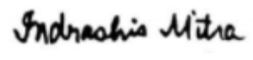_ ___
4.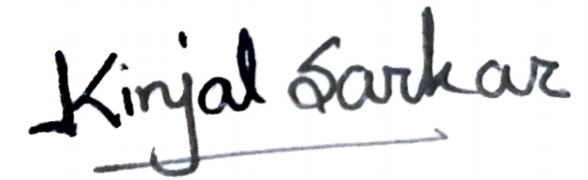
5._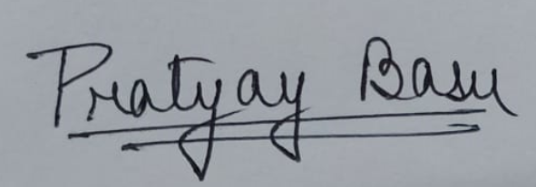

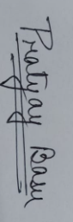
Consent of Faculty
Signature of Faculty: .___ Scanned Hand written Digital Signature
_PROF (DR) K B RAY

Without the Scanned Hand written Digital Signature of the students and the faculty member this form will not be accepted

